WARRANT OFFICER ASSOCIATION
CRATER CHAPTER # 0603
FORT LEE, VIRGINIA 23801

MEMORANDUM FOR RECORD DRAFT 12 December 2018

1. The Chapter Vice President, CW3P Alex Blain, called the meeting to order at 1740.

2. Quorum - 12 (29 proxies) present to conduct the meeting, 5 visitors; Pledge of Allegiance was recited.

3. We welcomed:
CW5 Thomas Elder, 920A, a first meeting member, assigned to the Quartermaster School
CW5 Thomas Waltman, 915E, coming from Pike Peak Chapter, Fort Carson, assigned to TLC for OD Proponency. He will change his affiliation to the Crater Chapter.
SFC (WOC) Tyrone Lander, QM, serving as instructor, who will attend the March 19 WOBC.
CW3 Kevin Cutchins, 915A, assigned to CASCOM, who is AGR, coming from NG to WO Proponency.
Ms Patricia Harper, from ACS.

4. CW3P Alex Blain presented a donation check to Ms Patricia Harper for $500, supporting ACS Holiday Festivities.

5. Minutes from the 7 November 2018 meeting were reviewed by all. CW5 Nicole Woodyard made a motion to accept the minutes subject to edit, and CW5 James Williams seconded. Motion passed.

6. The Treasurer’s report for November 2018 were read by all. CW5 Nicole Woodyard made a motion to accept the reports subject to audit, and CW5R Vickie Vachon seconded. The treasurer’s report for November passed.
.
7. Committee Reports:
a. Vice President Report CW43 Alex Blain - Includes Membership statistics with reports from the Vice-President for Army Reserve/National Guard Affairs – CW5 James Williams- Vice-President for Retired Affairs – VACANT- and Vice-President for Junior Warrant Officer affairs VACANT- (VP-JWO) WO1-CW2 TBD - see report.
b. Memorabilia – CW3 Karen Algernon-Wallace. See report. See report.
c. Rebuilding Tri-Cities* Open – suspended due to ‘no committee lead’, open for quorum motion to remove from support list of Crater Chapter Activites/
d. Volunteer Hour monitor*. CW5R Vickie Vachon – see report.
e. Fund Raiser Event - 45 caliber Remington 1911 pistol – see Report – CW3 Wayne Sexton/CW4 Dan Howison

8. Old Business.

a. 2018 Election result were announced. Ballots were returned and the election was unanimous. There were no write in’s, and no issues raised. CW4 Dan Howison is elected President and CW3P Alex Blain is elected Vice President.
b. CW5 Joseph Giusto will swear in CW4 Dan Howison and CW3P Alex Blain on 9 January 2019. CW5 Thomas Waltman coordinated this with CW5 Giusto and CW5R Wayne Burton.
c. CW4R Amy Jones has coordinated Wreaths Across America. See Report. While discussing this topic, it was noted by CW5R Wayne Burton that in the ACS notes, that Blandford Church Cemetery is not covered by Wreaths across America. CW5R Vickie Vachon inquired as to whether that Cemetery is on the drop down select list when making donations for wreaths, and how to support that site. Blandford Church is not on the drop down, but may be a write in for purchase. Additionally, CW4R Amy Jones presents a $50 check from Wreaths Across America for the Chapter’s support. This is a completed action.
d. McGuire VA support. McGuire Christmas support, if not coordinated in December will move into early 2019 for action. CW5R Karen Ortiz is working to line up our Chapter interaction, and allow us to further coordinate Boy Scout assistance to deliver the gifts. IAW CW4R Duane Wallace, as a minimum, the Chapter can provide volunteers and support McGuire with donations for food. Date are yet determined. Notifications by email will go out
e CW5R Vickie Vachon, CW4 Dan Howison and CW5 Nicole Woodyard attended AAM. Receipts will not show on the Treasurer’s Report because each attendee funded their own travel. This is a completed action.
f. Holiday Helper coordinators are CW5 Travis Elliot and CW5 R Vickie Vachon. This is a completed action. See report.
g. Membership numbers reviewed during the VP report raised a quorum discussion on how to affect membership, how to increase desire to be a Crater member and participate in meetings. CW5R Wayne Burton stated that everyone operate basically on a “What’s in it for me” process. Perhaps a monthly raffle give a $30 meal ticket to meeting member attendees and spouse. CW5 Nicole Woodyard suggested we seek business funding in January. CW4 Destria Gladney will chair a membership drive, and contact ACS for how to set a table, perhaps, at the PX or Commissary area to attract Active duty and retired Warrant Officers. This is an open issue for review in January old business.

9. New business:

a. A Board of Director Meeting (BOD) will be held at the CRATER HUT 1700 Tuesday 8 January 2019. See Report.
b. Crater Secretary, CW5R Wayne Burton called USAWOA membership, and was able to make corrections on the Chapter Roster for some members status. Largely, these changes affected life-members. Basically, only the member can change chapter affiliation, address, phone number, email address, but status could be changed in some cases. Changes were: CW5R William Mullins status was changed. He was a life member, but is deceased. The following life member’s status were changed from Active to Retired. CW3R Adisa Aiyetoro, CW4R Percy Alexander, CW5R Kenneth Bittner, CW4R Monty Meston, and CW4R Duane Wallace. CW3 Wayne Sexton was changed from Active duty to NG. CW5R Paul Thurston (life) was changed from Army Reserve to Retired. This will permit more accurate numbers for our monthly Vice Presidents reports.

10. Motion to adjourn was made by CW3 Wayne Sexton, and was seconded by CW5 James Williams at 1845. Motion passed.

_____________________ ______________________
Wayne Burton Dan Y. Howison
Crater Chapter Secretary Crater Chapter President

Fund raising event. On 12 December 2018, SFC (WOC) Tyrone Lander reached his hand inside a Styrofoam cooler and pulled out ticket 461. That ticket was sold by CW3 Wayne Sexton to Mike Benson of Fort Pickett, Blackstone, Virginia.
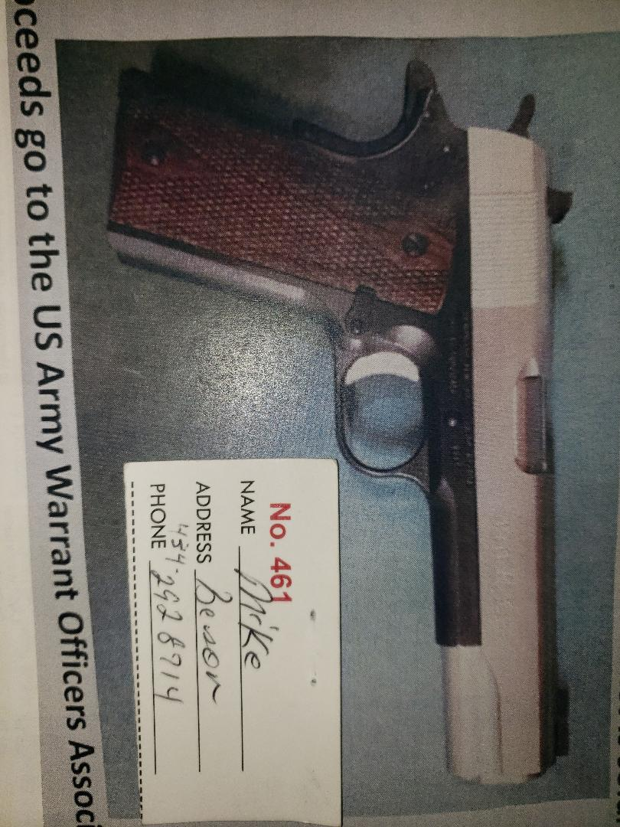

Imagine a picture of Mike Benson shaking hands with CW4 Dan Howison or CW3 Wayne Sexton, while receiving the pistol. Apologies, the situation did not permit a photo when CW4R Charlie Mills presented the pistol.
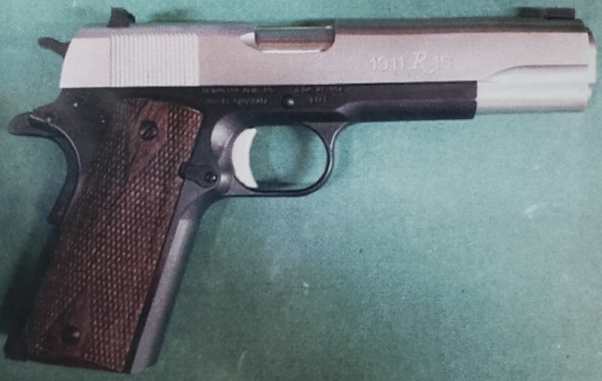

12 December 2018 Quorum
Crater Chapter Standing Orders:
1. Chapter President is authorized discretion to fund administrative purchases of up to $500, provided the budget contains funding. Such expenditures will be reviewed in the next Treasures Report minutes.
2. Two Scholarships are funded annually. One to a dependent of a Crater Member present in the local area and one open to student attending college in local area from the tri-cities area or other member dependent. All funds in the Chapter Savings are for Scholarships. Deviation from two scholarships or amount change in any year are actioned with a quorum motion and voting. Application guidelines are published in the entry form available on the Chapter website.
3. Chapter Memorabilia Chair is authorized to fund replenishment of existing memorabilia lines from sales proceeds up to $999.00 limit.
4. Chapter Treasure is bonded and signs all checks for Chapter expenditures; with actions reported in following Treasurer’s reports.
5. Chapter sends a representative to the AAM each year if funding is available. Raised and obligated annually NLT July permitting best scheduling and bargain travel costs.
6. Crater Chapter supports the following community events as Old Business:
- Rebuilding Tri-Cities/Habitat-for Humanity* suspended
- Thanksgiving Baskets
- Wreaths across America
- Holiday Helper
- Support for McGuire Veterans Home
All other community events are brought to the quorum as new business.

CW4 Dan Howison  CW5R Wayne Burton  CW5 Travis Elliott  CW4R Charlie Mills  CW5R Vickie Vachon  CW4R Edward Kalbach |  | CW3 Wayne Sexton  CW4 Alex Blain  CW5R Karen Ortiz  % CW5 Cindy Frazier  ! CW5 Thomas Elder  CW4 Destria Gladney | CW5 James Williams  CW5 Nicole Woodyard  ! CW5 Thomas Waltman  ! SFC WOC) Tyrone Lander  ! CW3 Kevin Cutchins  ! Ms Patricia Harper - ACS | * USAWOA member; not Crater Chapter member # membership unknown ! VISITOR  %Telephone Call in
ADDENDUM: Crater Chapter Proxies Held
Name Expires Proxy given to:
CW5R Frank Meeks Jul 19 CW5R Vickie Vachon
CW5 Roberto Figueroa Jan 19 CW5R Vickie Vachon
CW4R Luis Martinez Jan 19 CWR5 Vickie Vachon
CW5R Karen Ortiz Jan 19 CW5R Vickie Vachon
CW5 Guy Hunter Mar 19 CW5R Vickie Vachon
CW5 Vickie Vachon Jul 19 President or VP
CW4R Richard Jefferson Mar 19 VP
CW3 Joshua Martin Mar 19 President or VP
CW4 Robert D. Johnson Jul 19 President or VP
CW4 Wayne Melesky Nov 18 Presiding Officer
CW3R William King Mar 19 Presiding Officer
COLR David Buck Mar 19 Presiding Officer
CW4R Allan E Rickard Mar 19 Presiding Officer
CW5R Wayne Estes Mar 19 Presiding Officer
CW4R Donna Zampi Oct 19 President
CW5R Sam Galloway Nov 18 President
CW4 Adriana Aldape Mar 19 Open
CW4 Alex Blain Mar 19 Open
CW4 Clenora Walker Mar 19 Open
CW4 Ted Vanzant Mar 19 Open
CW5 James Williams Mar 19 Open
CW5 Jose Agosto Mar 19 Open
CW5 Robert Gowin Mar 19 Open
CW5R Alvin Taswell Aug 19 Open
CW5R Wayne Burton Jan 19 Open
CW4 Dan Howison Mar 19 Open
CW5 Nicole Woodyard Feb 19 Open
CW4R Hope Bean Jan 19 CW4R Amy Jones
CW4R Chester Morris Jan 19 Chapter President
CW4R Monty Meston Jan 19 CW5R Wayne Burton
Chapter BOD – Committee Structure
President+: CW4 Dan Howison dan.y.howison.mil@mail.mil Vice President+: CW4 Alex Blain alex.blain.mil@mail.mil Vice President for Army Reserve/NG Affairs –CW5 James Williams Vice President for Retired Affairs – CW5R Jack Van Zanten vjack730@aol.com Vice President for Junior Warrant Officer Affairs – OPEN @Membership – Filled by VP, VP-RA, VP RS-A, VP-JWO @ Memorabilia - CW3 Karen Algernon-Wallace karen.a.algernonwallace.mil@mail.mil
*Rebuilding Tri-Cities – OPEN @Nominations/Elections Committee – CW5R Wayne Burton & CW5R Vickie Vachon *Volunteer hour Monitor - CW5 Vickie Vachon (pokeandprod@aol.com ) *Holiday helper – *Web-Master – CW3 James McCracken james.mccracken13.mil@mail.mil Treasurer # – CW4R Charles Mills ( charlieandada@gmail.com ) Secretary# – CW5R Wayne Burton (waynebrv@yahoo.com; marion.w.burton.civ@mail.mil) *Resolutions/ Parliamentarian - CW5R Wayne Burton *Chaplain – OPEN *Crater 100th Committee CW5 Nicole Woodyard
*Special Committee + elected office # appointed office @ Committee IAW Bylaws
Note: All Elected/Appointed Officers and Committee leads will serve on Crater BOD.

All committee members & appointments are installed and removed at discretion of the Chapter President IAW current Chapter Bylaws
CW4R Amy Jones Aug 19 CW5R Wayne Burton
CW4R Percy Alexander Jan 19 CW5R Wayne Burton
CW3 Dan Peoples Mar 19 CW5R Wayne Burton
CW5 Travis Elliott Jan 19 CW5R Wayne Burton
CW5R Bob Gates Jan 19 CW5R Wayne Burton
CW4 Francis Pattin Jan 19 CW5R Wayne Burton
CW4R Charles L. Mills Mar 19 CW5R Wayne Burton
CW3 Ryan Harman Jan 19 CW4 Dan Howison
Proxies used:
Bronze Level - Eagle Rising Recipients:
CW5R Wayne Burton CW4 Dan Howison
CW4 Adriana Aldape CW4 Ted Vanzant
CW4 Francis Pattin CW4R Charlie Mills
CW2 Kevin Pick CW5 Nicole Woodyard USAWOA

Silver Level - Eagle Rising Recipients
CW4R Amy Jones CW5 James Williams
CW5 Nicole Woodyard USAOWA

Gold Level - Eagle Rising Recipients
CW5R Vickie Vachon CW5R Wayne Burton
CW5R Reggie Jacobs CW5 Travis Elliott
CW5 Guy Hunter CW5R Karen Ortiz
CW4 Adriana Aldape CW5 Nicole Woodyard USAOWA

NOTE: Revalidation is at least a 6 month process, therefore POA revalidation efforts must begin in February 2020, to meet Oct deadline.

Presidents’ Report – Verbal report at meeting.
Vice Presidents’ Report
Vice President NOTES:
CW3 Alex Blain– Chapter Vice President, CW5 James WIlliams VP – Reserve/NG Affairs, and VACANT VP- Retired Affairs and VP-JWO VP VACANT
VP Report - Roster
Crater Meeting Call in Number
641-715-3580 Access Code: 501219
Calling in to the Crater Meeting is like being here in person. If you are a member, YOU may participate, open motions, offer seconds, discuss and vote. We all are busy, and the Crater Chapter steps up to the 21st Century with live telephonic meeting!
Crater 2019-2020 Calendar Events
9 Jan 2019- Swear in elected new officers
6 Feb 2019 Chapter Meeting – HUT

6 Mar Chapter Meeting – HUT
3 Apr Warrant Officer Meet & Greet – HUT TIME -TBD
- Close Scholarship acceptance (1 April 2019)
1 May Chapter Meeting – HUT Meet and Greet
- announce scholarship winners
5 Jun Chapter Meeting - HUT
10 Jul Chapter Meeting - HUT
7 Aug Chapter Meeting - HUT
-Accept Nominations - approve Ballot
4 Sep Warrant Officer Meet & Greet - HUT TIME -TBD
- Final date to approve Ballot
2 Oct Chapter Meeting – HUT
TBD Oct 2019 47th AMM Fort Campbell, KY – Details to follow
- Habitat for Humanity
- McGuire Veterans Hospital Visit Planning list
- Present post with donation for Thanksgiving
6 Nov Chapter Meeting – HUT
- Holiday Helper planning list
- Wreaths Across America planning list
- Election Vote
- Present post with donation for Christmas
4 Dec Chapter Meeting - HUT
- Announce election results
- Holiday Helper execution
- Visit McGuire Veterans Hospital
- Wreaths Across America
8 Jan 2020- Swear in elected new officers
5 Feb 2020 – Crater paperwork needs filled out and submitted for Private Organization Revalidation
Items in yellow require clarity by quorum and Chapter Leadership
TOTAL - 138
ADW - 56
RET - 69
ASC - 1
NGW - 9
ARW - 3
LIFE -70
VOLUNTEER HOURS
Volunteer hours as they stand in the following spreadsheet:

Volunteer hours - 2 Dec FY19
32.5 for members
0 non members

Volunteer Hours (Need ages of volunteers always if younger than 18)

Also need following volunteer hours:

8 Jan 2019 BOD Meeting: 1700-1900
Attendance: CW4 Dan Howison by phone from Michigan, CW4 Alex Blain, CW5R Wayne Burton, CW5R Vickie Vachon, CW5R Karen Ortiz, CW5 Travis Elliott, CW4R Charlie Mills, CW5 Nicole Woodyard
1. Adjusted Calendar schedule, and finalize planning events.
2. Determined that Standing Orders without a Committee Chair nominated and working actions, are to be suspended, temporary, or brought to quorum vote for removal from Standing Order list. Standing orders are derivative from Bylaws, clarifying routine support.
3. Set committee of CW5R Wayne Burton, CW5R Vickie Vachon, and CW4R Charlie Mills to revise Bylaws in 5 year review schedule and action planned to be complete by April 2019.
4. CW5 Niclole Woodyard, and CW5R Wayne Burton will write memorandum, for 2019 local vendor support, with Chapter mission statement, and intent to support community for President’s signature, NLT March 2019.
5. Determined that the $903 proceeds from the 45 caliber donation raffle are insufficient to fully action new raffle purchase intent and community support. A quorum motion is required to direct the $903 specifically or it remains in Crater General funds.

MEMORIBIILIA REPORT
CW3 Karen Algernon-Wallace

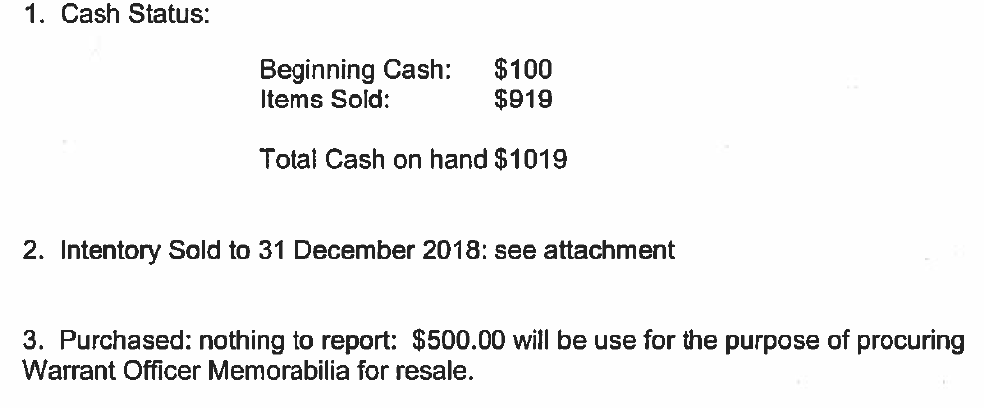

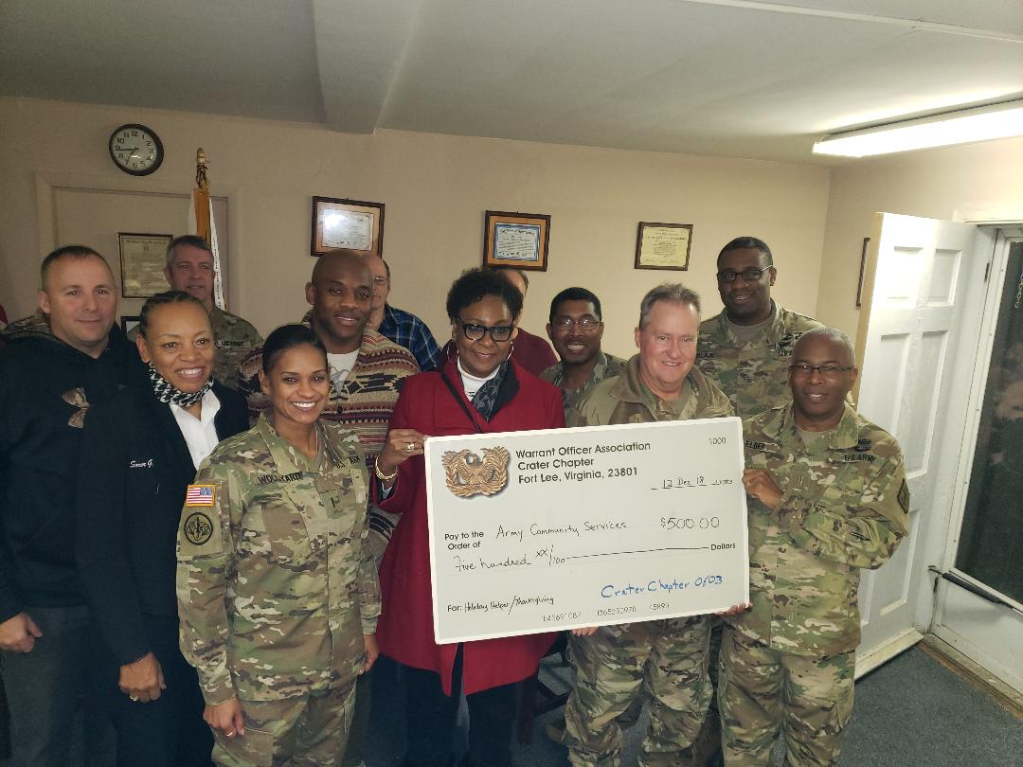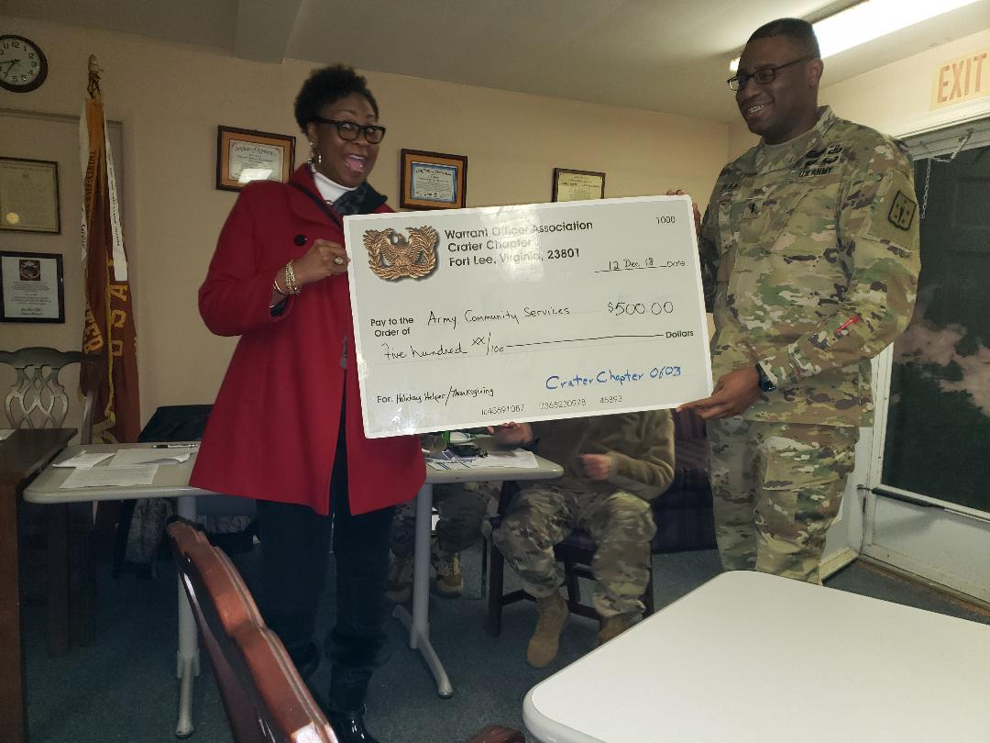

Wreaths Across America:
On December 15th, 2018 @ 11am, Crater Chapter Warrant Officer's Association helped City Point National Cemetery to remember and Honor our veterans by laying Remembrance Wreaths on the graves of our country's fallen heroes.

23 Crater Members and guest help us honor and remember as many fallen heroes as possible by sponsoring remembrance wreaths, and/or volunteering on Wreaths Day. # Boy Scouts of America members were present and assisted because Crater Chapter Sponsors BSA # 912.

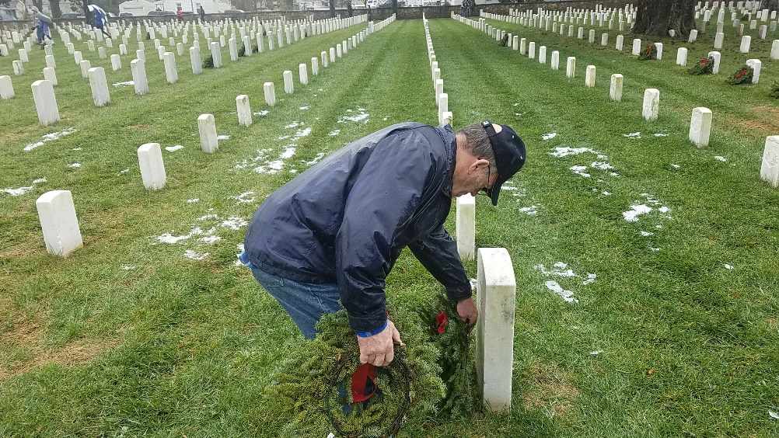
-CW5R Wayne Burton -CW5R Jack Van Zanten
-CW4R Charlie Mills -CW4R Amy Jones
-CW4 Dan Howison *Lonnie Jones
*Catherine Howison -CW5R Bob Gowin
-CW4 Francis Pattin -CW4R Luis Martinez
*Jordan Childs – age 14 -CW5R Karen Ortiz
*Myles Childs – age 16 *Aniya Tyler- 13
-CW4 James McCracken *Karyn Tyler- 11
*Riley McCracken age 10 *Debbie Sullivan
-CW4R Luis Sanchez *Sandra Sullivan
-CW4 Robert Johnson -CW5 Travis Elliott
*Erin Johnson

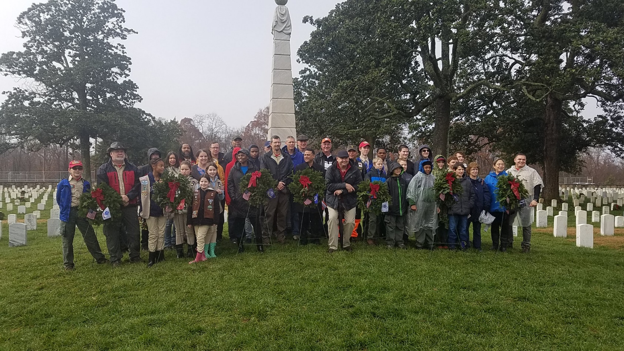

USAWOA CRATER CHAPTER
Treasurer’s Reports
1 December – 31 December 2018

Checking Account Fort Lee Federal Credit Union- Balance previous month $ 4,420.40

INCOME:
Raffle $1,605.00
PayPal $ 73.25
Income Total $1678.25 + $1,678.25

Expenses:
Operational Expenses
Meals $ 40.36 C/C
Mail Box Renewal $ 62.00 C/C
Raffle $ 621.27 Check# 118
Donation: MWR Thanksgiving $ 250.00 Check # 116
Donation: MWR Christmas $ 250.00 Check # 116
Donation: BSA Troop 912 $ 200.00 Check # 117
Transfer to Savings $1,000.00
Expenditures Total: $2,423.63 - $2,423.63
Total Revenue $ 3,675.02

Savings Account Fort Lee Federal Credit Union - Balance previous month $3,054.68
Income:
Interest $ 0.0
Deposit $1,000.00
TOTAL Income $1,000.00 + $1,000.00
Saving Account Balance: $4,054.68

Checking & Savings Account COMBINED TOTAL: $7,729.70

PLEDGED PAID
Mail Box: $62.00 $ 62.00
Liability Insurance: $268.00 $268.00
Bond: $114.82 $114.82
Scholarship Member: $1,000.00 0.00
Scholarship Community: $1,000.00 0.00
Thanksgiving Donation: $250.00 $250.00
Christmas Donation: $250.00 $250.00
AMM: $3,000.00 00.00
Re-Building Tri-City: $200.00 00.00
Scouts – BSA: $200.00 $200.00
Veterans Home: $300.00 00.00
TOTAL $6,674.82 $ 1,142.82

Pledged Donation for 2018 $6,674.82 Spent $1,142.82 Remaining Obligation $00.00
NO Scholarship Application received, No Money SPENT

Charles L. Mills Dan Y. Howison
CW4(R), OD CW4, OD
Crater Chapter Treasurer Crater Chapter President

Agenda January 9th, 2019 meeting
1. Count of members to ensure a forum/forum established ( ) ID Proxies ( )
2. Call meeting to order at _________________
3. Pledge
** CW5 Giusto swears in New Chapter President and Vice President
4. Welcome guest and new members
5. Minutes passed out and read, any discussion, motion to accept subject to edit
Motion made by ________________________________
Seconded By ___________________________________
6. Treasures Report read and any discussion, motion to accept subject to audit
Motion made by_________________________________
Seconded By ____________________________________
7. Committee Reports
a. Vice President Report CW4 Alex Blain – CW5 James Williams- CW5R Jack Van Zanten
b. Memorabilia – CW3 Karen Algernon-Wallace.
d. Volunteer Hours. CW5R Vickie Vachon.
e. Fund Raiser Event - NEW ! 45 caliber 1911 pistol ?– CW3 Wayne Sexton/CW4 Dan Howison

8. Old Business

Finalize the report for total proceeds from the Pistol $903 proceeds usage – close this action –info and discussion for vote

Membership and Proxies - action
Swear in new Chapter officers - CW5 Joseph Giusto - event
McGuire support – CW5R Ortiz (A Spring event?) discussion for vote
Wreaths Across America at Blandford Church Cemetery – CW5R Vickie Vachon - action
What’s in it for me” membership process – CW4 Destria Gladney –action
Committee of CW5R Wayne Burton, CW5R Vickie Vachon, and CW4R Charlie Mills to revise Bylaws–action
CW5 Nicole Woodyard, and CW5R Wayne Burton will write memorandum, for 2019 local vendor support, with Chapter mission statement, and intent to support community for President’s signature, NLT March 2019 –action
Standing Orders without a Committee Chair, nominated and working actions, are to be suspended, temporary, or brought to quorum vote for removal from Standing Order list – Remove Routine standing order support for Rebuilding Tricities? - ACTION
Add Standing Committee and support for Boy Scouts of America Troop 912 and Cub Scouts, if we have a Committee – Discussion for Action
9. New Business –
10. Alibi’s
11. Next Meeting - Hut 1700-1730 Social 1730-1830 February 6th
12. Adjourn meeting at (time) _________________________
Motion made by__________________________________
Seconded by _____________________________________

CRATER CHAPTER MEMBERS
Use the following instructions to update your personal information with WOA National.
Logon to USAWOA.net https://netforum.avectra.com/eweb/StartPage.aspx?Site=USAWOA
Pay particular attention to your current rank and primary email address.
**As of 31 March 2015, AKO Email is shut down. Effective 30 June 2015, all email addressed to @us.army.mil email accounts will be returned to sender**
Must change to @mail.mil or another personal email address
__________________________________________________________________________________________________________________________________________________________________________________________________________________________________________________________________________________________________________________________________________________________________________________________________________________________________________________________________________________________________________________________________________________________________________________________________________________________________________________________________________________________________________________________________________________________________________________________________________________________________________________________________________________________________________________________________________________________________________________________________________________________________________________________________________________________________________________________________________________________________________________________________________________________________________________________________________________________________________________________________________________________________________________________________________________________________

